80th Serra International Convention
Chiang Mai, Thailand
22 – 25 June 2023

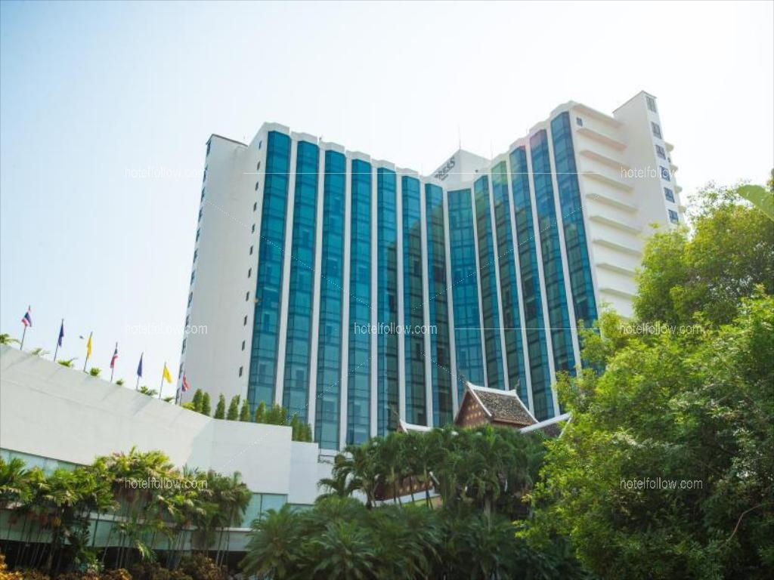

- An ideal full-scale and multifunctional convention center situated in the middle of Chiang Mai, and adjacent to a certified five-star luxury hotel
- The Empress Grand Hall can accommodate up to 2,500 delegates within its spacious 925 square meter area
- Other facilities include: 4 breakout boardrooms, 5 meeting rooms, business center, simultaneous interpretation facilities, registration counters, and VIP rooms
- Located within walking distance to the Sacred Heart of Jesus Cathedral and other Catholic institutions and communities, such as the Catholic Mission Center and three renowned Catholic schools
- Located within short driving distance to the iconic Night Market, the international airport, and the train station

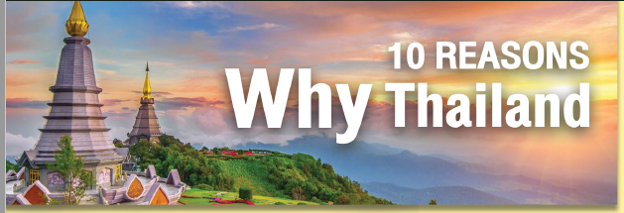

1. CHRISTIANITY IS RECOGNIZED AND PROTECTED BY THAI LAW
Although a predominantly Buddhist country, Thailand’s constitution prohibits religious discrimination. The constitution also protects the freedom of belief, so long as the exercise of this freedom does not harm the security of the State.

2. A GROWING CATHOLIC COMMUNITY
The Catholic community has approximately 400,000 members, over 600 priests, and over 500 parishes nationwide, where Chiang Mai is one of the largest and fastest growing communities. Furthermore, SERRA has a strong base in Thailand, with 3 Districts and almost 30 active Clubs that have been promoting vocations for the past 40 years.

3. CATHOLICISM’S DEEP ROOTS IN THAILAND
Roman Catholicism was first introduced to Siam (the former name of Thailand) by Portuguese Dominican missionaries in 1567. Since then, Catholics have had a constant presence and have contributed to the nation’s political and economic developments. In 2019, Thailand celebrated the 350th anniversary of the establishment of the Apostolic Vicariate of Siam. The celebrations culminated in a visit by His Holiness Pope Francis to Thailand.

4. EXPERIENCED AND DEDICATED TEAM OF THE LOCAL HOST
Asia hosted a Serra International Convention for the first time in 2005 in Bangkok, Thailand. Many attendees still talk about it as perhaps one of the best conventions ever. A key factor in this successful outcome was the experience, dedication, and warmth of the local host’s team. It has been more than 15 years since that legendary international convention, and we have learnt a few more tricks since then, so with the continued support of the local church and seminaries, the signs are good for a new Serra legend to be born.

5. STRONG SUPPORT FROM LOCAL PARTNERS, GOVERNMENT AGENCY, AND PRIVATE SECTORS
The SERRA Thailand Council has chosen Chiang Mai, Thailand’s northern capital, as the venue for the 80th Serra International Convention in 2023. On the Church side, the Catholic Bishops’ Conference of Thailand (Office of Seminary and Vocations), the Catholic Education Council of Thailand, and the local church communities have all pledged their full support for the event. In parallel, government agencies, in particular the Chiang Mai Provincial Administrative Organization and the Thailand Convention & Exhibition Bureau (TCEB) have been enthusiastic in their support.

6. INTERNATIONAL-STANDARD VENUE AND FACILITIES WITH HYGIENE MEASURES
The Empress Convention Centre is a large-scale, multifunctional convention center that can accommodate up to 2,500 delegates. It possesses a wide range of facilities and conference technologies to support physical, on-line, and hybrid meetings. In the wake of the COVID-19 pandemic, it has also instituted preventative hygiene measures to guarantee the venue’s cleanliness to the Royal Thai Government’s high standards.

7. EASY ACCESSIBILITY AND VISA-FRIENDLY COUNTRY
Thailand offers visa exemptions for 68 countries, while an additional 18 countries can apply for a “Visa on Arrival”. Travelling to Chiang Mai is easy and convenient, especially by air. Chiang Mai’s international airport receives more than 50 direct flights from Suvarnabhumi International Airport (BKK) in Bangkok, as well as direct flights to and from Beijing, Hanoi, Hong Kong, Taipei, Singapore, and Seoul.

9. ACCREDITED UNESCO CITY
In recognition of its local crafts and folk art, Chiang Mai has been designated as a UNESCO Creative City. The old town of Chiang Mai is captivating with its beautiful temples, awash with a charming classical atmosphere, natural attractions, and community-based tourism where the modern and traditional lifestyles are seamlessly combined.

8. CONVENTION HOTEL
The Empress Hotel, which has been chosen as the convention’s hotel, has one four-star and one five-star towers, both of which can display the world-renowned Thai hospitality at an affordable price. A mere 15 minutes from the airport by car, the hotel is conveniently located in the same compound as the Empress Convention Center where most of the convention activities will take place.

10. THE THAI WAY: WORLD-CLASS HOSPITALITY
Hospitality is in the DNA of the Thai people, hence Thailand’s reputation as the “Land of Smiles”. In our culture, we are brought up to take care of others and put the guests’ needs above our own. With our service-minded mentality, foreign visitors have always and continue to feel warm and welcomed here.

MESSAGE FROM THE ORGANIZING COMMITTEE

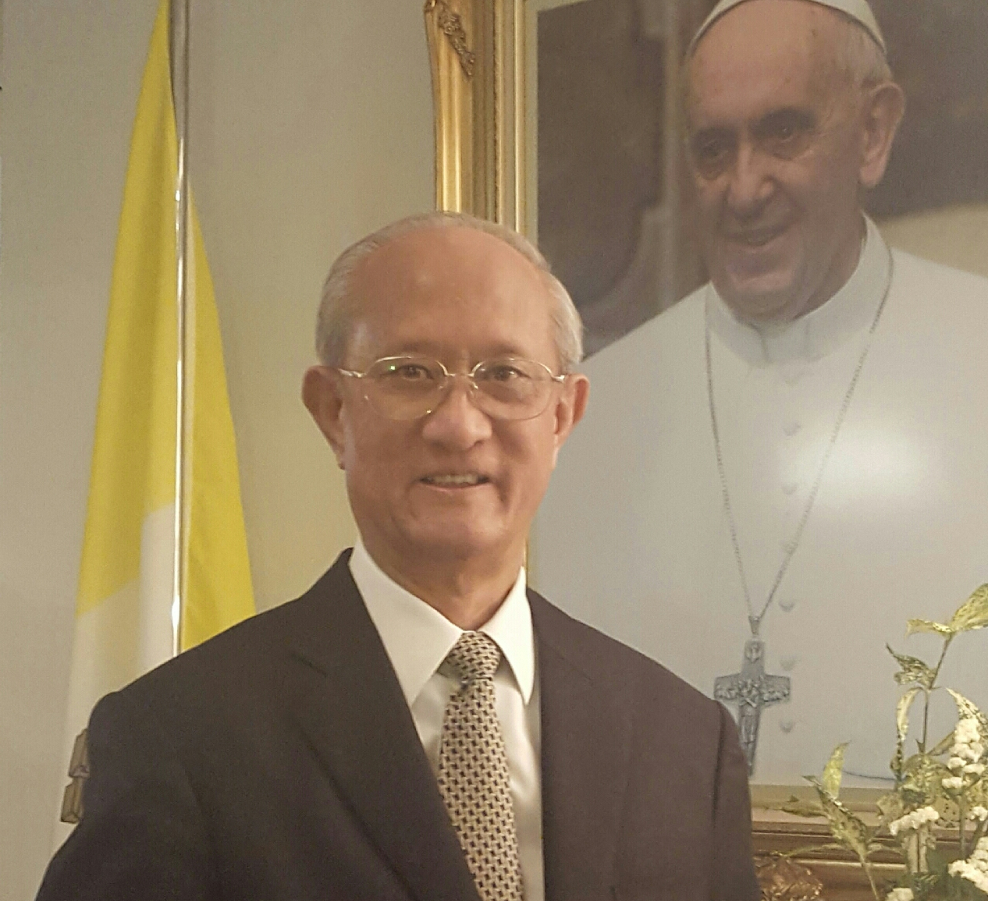

On behalf of Serra Council of Thailand and the Catholic Bishops’ Conference of Thailand (Office of Seminaries and Vocations), it is my pleasure to cordially invite all fellow Serrans, spouses and friends to visit Thailand again and participate in the 80th Serra International Convention in Chiang Mai in June 2023.
Our convention organizers have already in mind planned a program balancing spiritually uplifting talks, fellowship and fun with special activities by young people who are the future of Serra and the Church.
Chiang Mai in the north of Thailand has been chosen as a host city because of its high potential convention city and the designated UNESCO Creative City of crafts and folk art. Its rich in culture is seen everywhere, from the numerous Buddhist temples with intricate northern architecture to its delicious cuisine, from encountering elephants in a sanctuary to weekend walking streets that will make the convention even more memorable.
I am confident that the supports from dynamic catholic communities in Thailand including the Diocese of Chiang Mai and Thailand Convention & Exhibition Bureau, together with our enthusiasm and readiness to be a host, will guarantee another great success in this 80th Serra International Convention. And, beyond expectations again.
We look forward to welcoming you to Chiang Mai and the Kingdom of Thailand.
Mary, mother of vocations, pray for us.
Chainarong Monthienvichienchai
Chairman of the organizing committee for the 80th SI Convention
cmonthien@gmail.com

